MAD LAB CYCLE -2

**1.** **Create 2 Activities from 1st Activity on click move to 2nd activity (Using Intent)**

**Program code:**

**Xml code**

**Activity_main.xml:**

*<?***xml version="1.0" encoding="utf-8"***?>*

<**LinearLayout xmlns:android="http://schemas.android.com/apk/res/android"**

**android:id="@+id/activity_main"**

**android:layout_width="match_parent"**

**android:layout_height="match_parent"**

**android:orientation="vertical"**>

<**TextView**

**android:layout_width="match_parent"**

**android:layout_height="wrap_content"**

**android:text="First Activity"**

**android:textStyle="bold"**

**android:layout_marginTop="10dp"**

**android:textAlignment="center"**

**style="@style/Animation.AppCompat.Dialog"**

**android:textSize="30dp"**/>

<**Button**

**android:text="Click Me"**

**android:layout_width="match_parent"**

**android:layout_height="wrap_content"**

**android:id="@+id/button"**

**android:onClick="click"**

**android:textStyle="bold"**

**android:layout_marginTop="200dp"**

**android:background="#34eb3a"**

**android:textSize="30dp"**/>

</**LinearLayout**>

**Activity2_main.xml:**

*<?***xml version="1.0" encoding="utf-8"***?>*

<**LinearLayout xmlns:android="http://schemas.android.com/apk/res/android"**

**android:id="@+id/activity_main2"**

**android:layout_width="match_parent"**

**android:layout_height="match_parent"**

**android:orientation="vertical"**>

<**TextView**

**android:layout_width="match_parent"**

**android:layout_height="wrap_content"**

**android:text="Second Activity"**

**android:textStyle="bold"**

**android:layout_marginTop="10dp"**

**android:textSize="30dp"**

**android:textAlignment="center"**/>

<**Button**

**android:text="Go Back"**

**android:layout_width="match_parent"**

**android:layout_height="wrap_content"**

**android:id="@+id/button2"**

**android:onClick="clickback"**

**android:textSize="30dp"**

**android:background="#34eb3a"**

**android:layout_marginTop="200dp"**/>

</**LinearLayout**>

**Java**

**Activity_main.java:**

**package** com.example.sjcet.pgm1_2activity;

**import** android.content.Intent;

**import** android.support.v7.app.AppCompatActivity;

**import** android.os.Bundle;

**import** android.view.View;

**public class** MainActivity **extends** AppCompatActivity {

@Override

**protected void** onCreate(Bundle savedInstanceState) {

**super**.onCreate(savedInstanceState);

setContentView(R.layout.***activity_main***);

}

**public void** click(View view) {

Intent intent = **new** Intent(MainActivity.**this**, Main2Activity.**class**);

startActivity(intent);

}

}

**Activity2_main.java:**

**package** com.example.sjcet.pgm1_2activity;

**import** android.content.Intent;

**import** android.support.v7.app.AppCompatActivity;

**import** android.os.Bundle;

**import** android.view.View;

**public class** Main2Activity **extends** AppCompatActivity {

@Override

**protected void** onCreate(Bundle savedInstanceState) {

**super**.onCreate(savedInstanceState);

setContentView(R.layout.***activity_main2***);

}

**public void** clickback(View view) {

Intent intent = **new** Intent(Main2Activity.**this**, MainActivity.**class**);

startActivity(intent);

}

}

**Output**

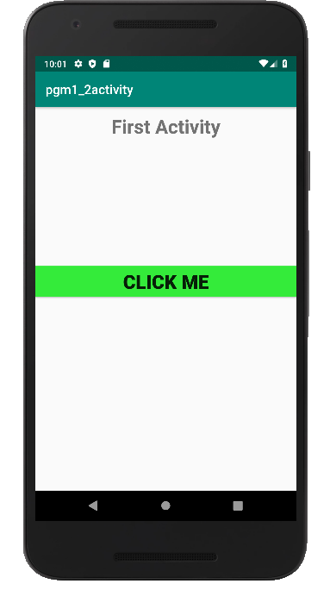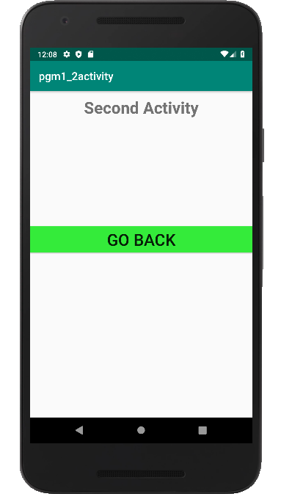

**2. Create an Activity and move to facebook login page on a button click**

**(making use of Intent).**

**Program code:**

**Xml code**

**Activity_main.xml:**

*<?***xml version="1.0" encoding="utf-8"***?>*

<**LinearLayout android:layout_width="match_parent"**

**android:layout_height="match_parent"**

**android:orientation="vertical"**

**xmlns:android="http://schemas.android.com/apk/res/android"**>

<**Button**

**android:onClick="click"**

**android:layout_width="wrap_content"**

**android:layout_height="wrap_content"**

**android:text="Facebook login"**

**android:layout_centerInParent="true"**

**android:textAlignment="center"**

**android:layout_gravity="center"**

**android:background="#006aff"**

**android:textColor="#fff"**/>

</**LinearLayout**>

**Java**

**Activity_main.java:**

**package** com.example.sjcet.pgm2_fbpage;

**import** android.content.Intent;

**import** android.net.Uri;

**import** android.support.v7.app.AppCompatActivity;

**import** android.os.Bundle;

**import** android.view.View;

**public class** MainActivity **extends** AppCompatActivity {

@Override

**protected void** onCreate(Bundle savedInstanceState) {

**super**.onCreate(savedInstanceState);

setContentView(R.layout.***activity_main***);

}

**public void** click(View view) {

String url = **"https://www.facebook.com"**;

Intent i = **new** Intent(Intent.***ACTION_VIEW***);

i.setData(Uri.*parse*(url));

startActivity(i);

}

}

**Output**

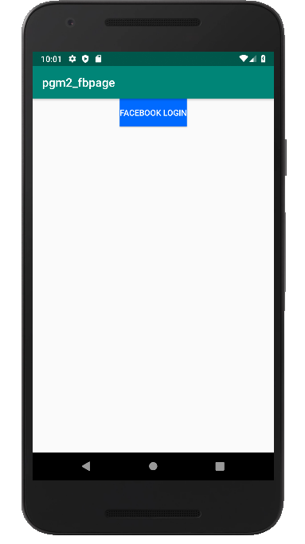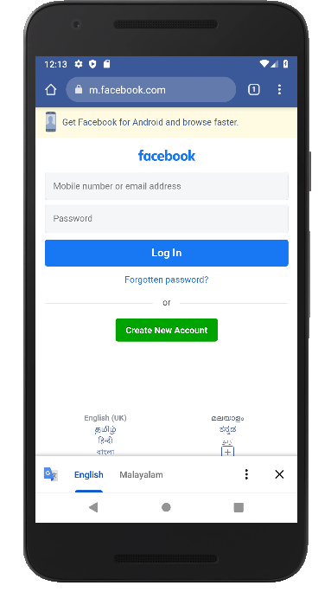

**3. Read message from 1st Activity and pass it onto the 2nd Activity on a button click.**

**Xml code**

**Activity_main.xml:**

***<?*xml version="1.0" encoding="utf-8"*?>***

<**LinearLayout xmlns:android="http://schemas.android.com/apk/res/android"**

**android:id="@+id/activity_main"**

**android:layout_width="match_parent"**

**android:layout_height="match_parent"**

**android:orientation="vertical"**>

<**TextView**

**android:layout_width="match_parent"**

**android:layout_height="wrap_content"**

**android:text="First Activity"**

**android:textStyle="bold"**

**android:layout_marginTop="10dp"**

**android:textAlignment="center"**

**android:textSize="30dp"**/>

<**EditText**

**android:layout_width="match_parent"**

**android:layout_height="wrap_content"**

**android:hint="Text"**

**android:textColor="#000000"**

**android:textSize="20dp"**

**android:textStyle="bold"**

**android:id="@+id/text"** />

<**Button**

**android:text="Click here"**

**android:layout_width="match_parent"**

**android:layout_height="wrap_content"**

**android:id="@+id/button"**

**android:onClick="click"**

**android:textStyle="bold"**

**android:textSize="30dp"**

**android:background="#ff00ae"**

**android:textColor="#fff"**

**android:layout_gravity="center_vertical"** />

</**LinearLayout**>

**Activity2_main.xml:**

***<?*xml version="1.0" encoding="utf-8"*?>***

<**LinearLayout xmlns:android="http://schemas.android.com/apk/res/android"**

**android:id="@+id/activity_main2"**

**android:layout_width="match_parent"**

**android:layout_height="match_parent"**

**android:orientation="vertical"**>

<**TextView**

**android:layout_width="match_parent"**

**android:layout_height="wrap_content"**

**android:text="Second Activity"**

**android:textStyle="bold"**

**android:layout_marginTop="10dp"**

**android:textAlignment="center"**

**android:textSize="30dp"**/>

<**TextView**

**android:layout_width="match_parent"**

**android:layout_height="wrap_content"**

**android:textSize="30dp"**

**android:textColor="#000000"**

**android:id="@+id/textreceived"**

/>

<**Button**

**android:text="Go Back"**

**android:layout_width="match_parent"**

**android:layout_height="wrap_content"**

**android:id="@+id/button2"**

**android:textSize="30dp"**

**android:background="#ff00ae"**

**android:onClick="click"**/>

</**LinearLayout**>

**Java**

**Activity_main.java:**

**package com.example.sjcet.pgm3_copymsg;**

**import** android.content.Intent;

**import** android.support.v7.app.AppCompatActivity;

**import** android.os.Bundle;

**import** android.view.View;

**import** android.widget.Button;

**import** android.widget.EditText;

**public class** MainActivity **extends** AppCompatActivity {

EditText **text**;

Button **clickme**;

String **Texthere**;

@Override

**protected void** onCreate(Bundle savedInstanceState) {

**super**.onCreate(savedInstanceState);

setContentView(R.layout.***activity_main***);

**clickme** = findViewById(R.id.***button***);

**text** = findViewById(R.id.***text***);

**clickme**.setOnClickListener(**new** View.OnClickListener() {

@Override

**public void** onClick(View v) {

**Texthere** = **text**.getText().toString();

Intent intent = **new** Intent(MainActivity.**this**, Main2Activity.**class**);

intent.putExtra(**"Text"**, **Texthere**);

startActivity(intent);

}

});

}

}

**Activity2_main.java:**

**package com.example.sjcet.pgm3_copymsg;**

**import** android.content.Intent;

**import** android.support.v7.app.AppCompatActivity;

**import** android.os.Bundle;

**import** android.view.View;

**import** android.widget.Button;

**import** android.widget.TextView;

**public class** Main2Activity **extends** AppCompatActivity {

TextView **textreceived**;

Button **button2**;

String **text**;

@Override

**protected void** onCreate(Bundle savedInstanceState) {

**super**.onCreate(savedInstanceState);

setContentView(R.layout.***activity_main2***);

**text** = getIntent().getExtras().getString(**"Text"**);

**textreceived** = findViewById(R.id.***textreceived***);

**textreceived**.setText(**text**);

**button2** = findViewById(R.id.***button2***);

**button2**.setOnClickListener(**new** View.OnClickListener() {

@Override

**public void** onClick(View v) {

Intent intent = **new** Intent(Main2Activity.**this**, MainActivity.**class**);

startActivity(intent);

}

});

}

}

**Output**

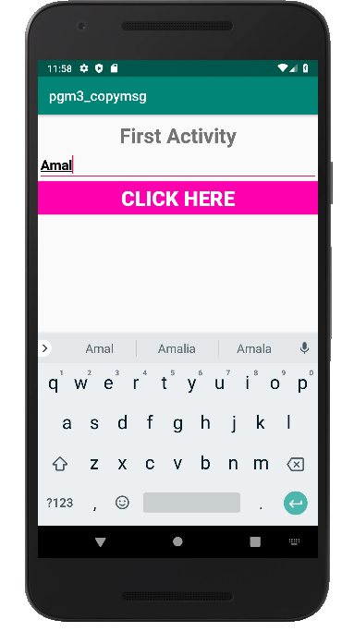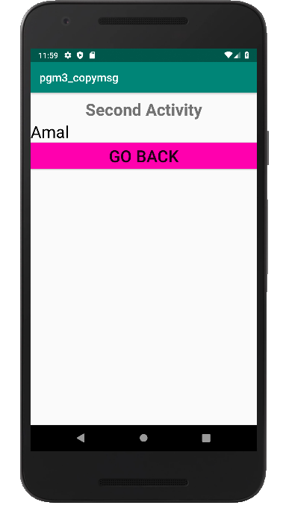

**4.Create registration page with full validation and pass the information to the second activity (using shared preference)**

**Mandatory fields : fname,lname,gender,email,phone number,password,dob(date picker)**

**Program code:**

**Xml code**

**Activity_main.xml:**

<ScrollView xmlns:tools="http://schemas.android.com/tools"

**android:layout_width="match_parent"**

**android:layout_height="match_parent"**

**xmlns:android="http://schemas.android.com/apk/res/android"**

**tools:context=".MainActivity"**>

<**LinearLayout xmlns:android="http://schemas.android.com/apk/res/android"**

**android:layout_width="match_parent"**

**android:layout_height="match_parent"**

**android:orientation="vertical"**

**android:padding="10dp"**>

<**TextView**

**android:layout_width="match_parent"**

**android:layout_height="wrap_content"**

**android:background="@color/colorAccent"**

**android:text="Register"**

**android:textAlignment="center"**

**android:textColor="#00fff7"**

**android:textSize="15dp"**

**android:textStyle="bold"** />

<**TextView**

**android:layout_width="wrap_content"**

**android:layout_height="wrap_content"**

**android:layout_gravity="center"**

**android:text="Firstname"**

**android:textStyle="bold"** />

<**EditText**

**android:id="@+id/fname"**

**android:layout_width="match_parent"**

**android:layout_height="wrap_content"**

**android:background="#fff"**

**android:hint="Enter Firstname"** />

<**TextView**

**android:layout_width="wrap_content"**

**android:layout_height="wrap_content"**

**android:layout_gravity="center"**

**android:text="Lastname"**

**android:textStyle="bold"** />

<**EditText**

**android:id="@+id/lname"**

**android:layout_width="match_parent"**

**android:layout_height="wrap_content"**

**android:background="#fff"**

**android:hint="Enter Lastname"** />

<**TextView**

**android:layout_width="wrap_content"**

**android:layout_height="wrap_content"**

**android:layout_gravity="center"**

**android:text="Gender"**

**android:textStyle="bold"** />

<**RadioGroup**

**android:id="@+id/gender"**

**android:layout_width="match_parent"**

**android:layout_height="wrap_content"**

**android:orientation="horizontal"**>

<**RadioButton**

**android:id="@+id/male"**

**android:layout_width="139dp"**

**android:layout_height="22dp"**

**android:text="Male"** />

<**RadioButton**

**android:id="@+id/female"**

**android:layout_width="107dp"**

**android:layout_height="22dp"**

**android:text="Female"** />

</**RadioGroup**>

<**TextView**

**android:layout_width="wrap_content"**

**android:layout_height="wrap_content"**

**android:layout_gravity="center"**

**android:text="Email"**

**android:textStyle="bold"** />

<**EditText**

**android:id="@+id/email"**

**android:layout_width="match_parent"**

**android:layout_height="wrap_content"**

**android:background="#fff"**

**android:hint="Enter Email"** />

<**TextView**

**android:layout_width="wrap_content"**

**android:layout_height="wrap_content"**

**android:layout_gravity="center"**

**android:text="Phone Number"**

**android:textStyle="bold"** />

<**EditText**

**android:id="@+id/phoneno"**

**android:layout_width="match_parent"**

**android:layout_height="wrap_content"**

**android:background="#fff"**

**android:hint="Enter Phone Number"** />

<**TextView**

**android:layout_width="wrap_content"**

**android:layout_height="wrap_content"**

**android:layout_gravity="center"**

**android:text="password"**

**android:textStyle="bold"** />

<**EditText**

**android:id="@+id/password"**

**android:layout_width="match_parent"**

**android:layout_height="wrap_content"**

**android:background="#fff"**

**android:hint="Enter password"** />

<**TextView**

**android:layout_width="wrap_content"**

**android:layout_height="wrap_content"**

**android:layout_gravity="center"**

**android:text="Date of Birth"**

**android:textStyle="bold"** />

<**ScrollView xmlns:android="http://schemas.android.com/apk/res/android"**

**android:layout_width="match_parent"**

**android:layout_height="match_parent"**>

<**DatePicker**

**android:id="@+id/dob"**

**android:layout_width="match_parent"**

**android:layout_height="273dp"**

**android:datePickerMode="spinner"**>

</**DatePicker**>

</**ScrollView**>

<**Button**

**android:id="@+id/btsubmit"**

**android:layout_width="match_parent"**

**android:layout_height="23dp"**

**android:layout_marginTop="10sp"**

**android:background="@color/colorAccent"**

**android:text="submit"**

**android:textColor="#00fff7"**

**android:textSize="15dp"**

**android:textStyle="bold"** />

</**LinearLayout**>

</**ScrollView**>

**Activity2_main.xml:**

*<?*xml version="1.0" encoding="utf-8"*?>*

<**LinearLayout android:layout_width="match_parent"**

**android:layout_height="match_parent"**

**xmlns:android="http://schemas.android.com/apk/res/android"**

**android:orientation="vertical"**

**android:layout_gravity="center"**>

<**TextView**

**android:layout_width="match_parent"**

**android:layout_height="wrap_content"**

**android:textSize="25dp"**

**android:textColor="#9eff0000"**

**android:text="welcome"**

**android:textAlignment="center"**/>

<**TextView**

**android:id="@+id/text_fullname"**

**android:layout_width="match_parent"**

**android:layout_height="wrap_content"**

**android:textSize="18dp"**

**android:textColor="#9e001eff"**

**android:text="full_name-"**

**android:layout_gravity="center"**

**android:textStyle="bold"**

**android:layout_margin="20dp"**/>

<**TextView**

**android:id="@+id/text_email"**

**android:layout_width="match_parent"**

**android:layout_height="wrap_content"**

**android:textSize="18dp"**

**android:textColor="#9e001eff"**

**android:text="email-"**

**android:layout_gravity="center"**

**android:textStyle="bold"**

**android:layout_margin="20dp"**/>

<**Button**

**android:id="@+id/blogout"**

**android:layout_width="wrap_content"**

**android:layout_height="wrap_content"**

**android:text="Logout"**

**android:layout_gravity="center"**

**android:layout_margin="20dp"**

**android:background="#00e6ff"**/>

</**LinearLayout**>

**Java**

**Activity_main.java:**

package com.example.sjcet.pgm4_regvalid;

**import** android.content.Intent;

**import** android.content.SharedPreferences;

**import** android.support.v7.app.AppCompatActivity;

**import** android.os.Bundle;

**import** android.view.View;

**import** android.widget.Button;

**import** android.widget.DatePicker;

**import** android.widget.EditText;

**import** android.widget.RadioButton;

**import** android.widget.RadioGroup;

**import** android.widget.Toast;

**public class** MainActivity **extends** AppCompatActivity {

EditText **firstname**, **lastname**, **uemail**, **uphoneno**, **upassword**;

RadioGroup **gender**;

DatePicker **dob**;

Button **btnsubmit**;

SharedPreferences **sharedPreferences**;

**private static final** String ***SHARED_PREF_NAME*** = **"mypref"**;

**private static final** String ***KEY_NAME*** = **"name"**;

**private static final** String ***KEY_EMAIL*** = **"email"**;

@Override

**protected void** onCreate(Bundle savedInstanceState) {

**super**.onCreate(savedInstanceState);

setContentView(R.layout.***activity_main***);

**firstname** = findViewById(R.id.***fname***);

**lastname** = findViewById(R.id.***lname***);

**uemail** = findViewById(R.id.***email***);

**uphoneno** = findViewById(R.id.***phoneno***);

**upassword** = findViewById(R.id.***password***);

**gender** = findViewById(R.id.***gender***);

**dob** = findViewById(R.id.***dob***);

**btnsubmit** = findViewById(R.id.***btsubmit***);

**sharedPreferences** = getSharedPreferences(***SHARED_PREF_NAME***,***MODE_PRIVATE***);

String name = **sharedPreferences**.getString(***KEY_NAME***,**null**);

**if** (name != **null**) {

Intent intent = **new** Intent(MainActivity.**this**,Main2Activity.**class**);

startActivity(intent);

}

**btnsubmit**.setOnClickListener(**new** View.OnClickListener() {

@Override

**public void** onClick(View v) {

SharedPreferences.Editor editor = **sharedPreferences**.edit();

editor.putString(***KEY_NAME***,**firstname**.getText().toString());

editor.putString(***KEY_EMAIL***,**uemail**.getText().toString());

editor.apply();

Intent intent = **new** Intent(MainActivity.**this**,Main2Activity.**class**);

startActivity(intent);

Toast.*makeText*(MainActivity.**this**, **""**, Toast.***LENGTH_SHORT***).show();

}

});

}

}

**Activity2_main.java:**

**package com.example.sjcet.pgm4_regvalid;**

**import** android.content.SharedPreferences;

**import** android.support.v7.app.AppCompatActivity;

**import** android.os.Bundle;

**import** android.view.View;

**import** android.widget.Button;

**import** android.widget.TextView;

**import** android.widget.Toast;

**public class** Main2Activity **extends** AppCompatActivity {

TextView **text_fullname**,**text_email**;

Button **blogout**;

SharedPreferences **sharedPreferences**;

**private static final** String ***SHARED_PREF_NAME*** = **"mypref"**;

**private static final** String ***KEY_NAME*** = **"name"**;

**private static final** String ***KEY_EMAIL*** = **"email"**;

@Override

**protected void** onCreate(Bundle savedInstanceState) {

**super**.onCreate(savedInstanceState);

setContentView(R.layout.***activity_main2***);

**text_email** = findViewById(R.id.***text_email***);

**text_fullname** = findViewById(R.id.***text_fullname***);

**blogout** = findViewById(R.id.***blogout***);

**sharedPreferences** = getSharedPreferences(***SHARED_PREF_NAME***,***MODE_PRIVATE***);

String name = **sharedPreferences**.getString(***KEY_NAME***,**null**);

String email = **sharedPreferences**.getString(***KEY_EMAIL***, **null**);

**if** (name != **null** || email != **null**){

**text_fullname**.setText(**"Full Name- "**+name);

**text_email**.setText(**"Email ID- "**+email);

}

**blogout**.setOnClickListener(**new** View.OnClickListener() {

@Override

**public void** onClick(View v) {

SharedPreferences.Editor editor = **sharedPreferences**.edit();

editor.clear();

editor.commit();

finish();

Toast.*makeText*(Main2Activity.**this**,**"logged out successfully"**,Toast.***LENGTH_SHORT***).show();

}

});

}

}

**Output**

